Week 2 homework

1. What is arithmetic overflow? When does it occur and how can it be detected?

**arithmetic overflow:** 1. In a [digital computer](https://www.its.bldrdoc.gov/fs-1037/dir-011/_1640.htm), the condition that occurs when a calculation produces a result that is greater than a given [register](https://www.its.bldrdoc.gov/fs-1037/dir-031/_4517.htm) or [storage](https://www.its.bldrdoc.gov/fs-1037/dir-035/_5134.htm) location can store or represent.

The sum of two identically-signed numbers may very well exceed the range of the bit field of those two numbers, and so in this case overflow is a possibility.

* When two signed 2's complement numbers are added, overflow is detected if:
  1. both operands are positive and the result is negative, or
  2. both operands are negative and the result is positive.
* When two unsigned numbers are added, overflow occurrs if
  1. there is a **carry out** of the leftmost bit.

2.

Draw a truth table to represent the intermediate values and output of the circuit below.

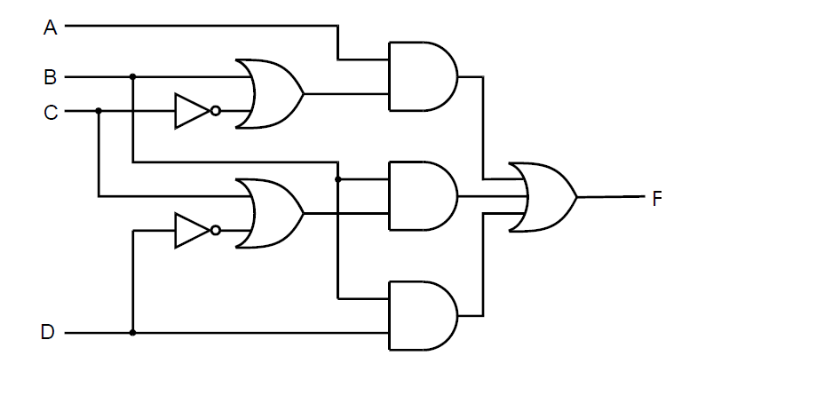

|  |  |  |  |  |
| --- | --- | --- | --- | --- |
| Input A | Input B | Input C | Input D | Output F |
| 0 | 0 | 0 | 0 | 0 |
| 0 | 0 | 0 | 1 | 0 |
| 0 | 0 | 1 | 0 | 0 |
| 0 | 0 | 1 | 1 | 0 |
| 0 | 1 | 0 | 0 | 1 |
| 0 | 1 | 0 | 1 | 0 |
| 0 | 1 | 1 | 0 | 1 |
| 0 | 1 | 1 | 1 | 1 |
| 1 | 0 | 0 | 0 | 1 |
| 1 | 0 | 0 | 1 | 1 |
| 1 | 0 | 1 | 0 | 0 |
| 1 | 0 | 1 | 1 | 0 |
| 1 | 1 | 0 | 0 | 1 |
| 1 | 1 | 0 | 1 | 1 |
| 1 | 1 | 1 | 0 | 1 |
| 1 | 1 | 1 | 1 | 1 |

3.

Draw a truth table for the circuit below and explain what it does.

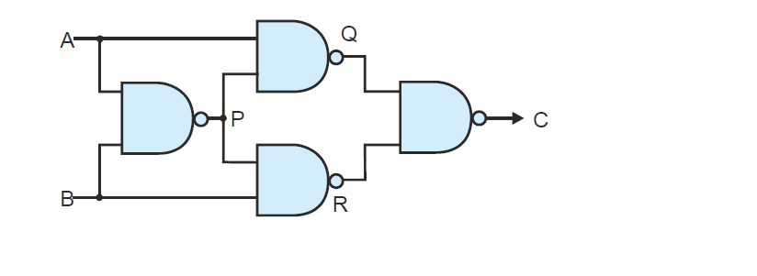

|  |  |  |
| --- | --- | --- |
| Input A | Input B | Output C |
| 0 | 0 | 0 |
| 0 | 1 | 1 |
| 1 | 0 | 1 |
| 1 | 1 | 0 |